Transferring Home Ownership in HubSpot Service Portal
It is not uncommon for a homeowner to sell their new home within a year of taking possession. When this happens, the new homeowner is still covered by the home warranty. To ensure a smooth transition, transferring access to the MyHome Portal from the original homeowner (Homeowner 1) to the new homeowner (Homeowner 2) is important.
Assets You Will Need to Access
To transfer home ownership in HubSpot Service Portal, you will need to access the following areas of HubSpot:
- Contact record for the original homeowner (Homeowner 1)
- Contact record for the new homeowner (Homeowner 2)
- The two MyHome pages for the home being transferred
- Membership Lists
For easier navigation, it is recommended that you open each of these pages in separate browser tabs.
Removing Homeowner 1 from MyHome Pages
The first step in transferring homeownership is by removing Homeowner 1:
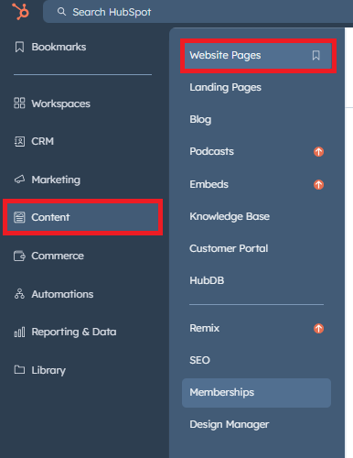
- First, sign in to your HubSpot account to access the Website Pages in HubSpot. Then, on the left-hand side menu, click on the Content option. From the expanded options, select Website Pages.

- After navigating to the Website Pages section in HubSpot, locate the Search Content field. Click on it and enter the job number associated with the home of Homeowner 1. This will bring up the Dashboard and Document pages for Homeowner 1’s portal in the search results.

- Open each page in a new browser tab by right-clicking the link and choosing that option from the menu.
- Once on each portal page, click on Settings at the top and then on Audience Access in the drop-down menu.
- Under Access group membership required, remove the list currently populated to the field and click the Public radio button. Click out of this pop-up window. These changes will automatically save.

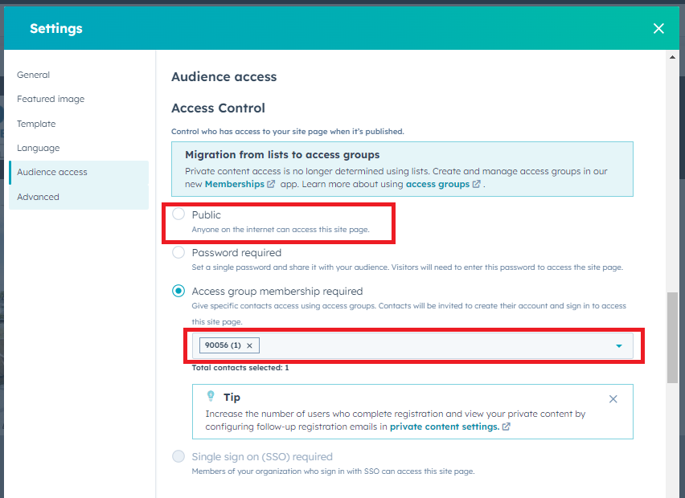
- Click Update in the top right-hand corner.

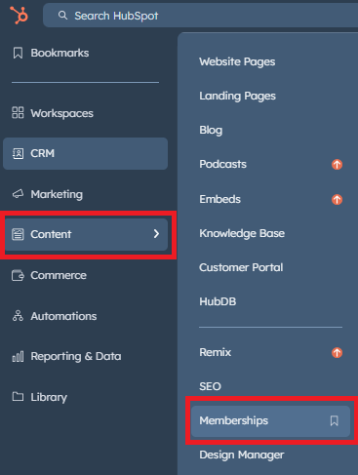
            - Navigate to Memberships by clicking on Content in the main menu and then on Memberships in the sub-menu.

- Search for the membership list for the job number associated with Homebuyer 1. If there is a small number of memberships, a search box will not populate, and finding the job number will be simple.
- Select Homeowner 1’s name on the list and click on Delete. You will then be prompted to confirm the removal.
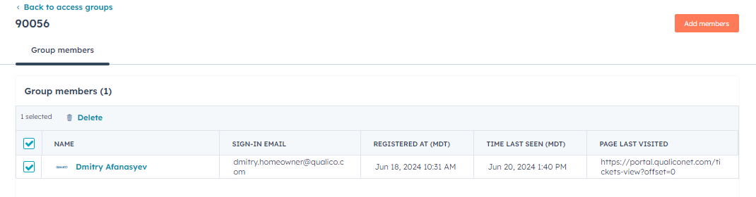

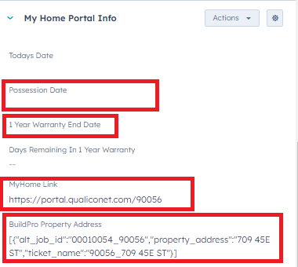
Transferring Warranty Info from Homeowner 1 to Homeowner 2.
- Next, navigate to the contact record for Homeowner 1.
                - On the left-hand side of the screen, transfer the data in the following fields from Homeowner 1 to the same fields on the contact record for Homeowner 2.
  - Possession Date
  - 1 Year Warranty End Date
  - MyHome Link
  - BuildPro Property Address

Once you have transferred the warranty information from Homeowner 1 to Homeowner 2, remove the warranty data from the fields on Homeowner 1’s contact record.
Adding Homeowner 2 to the Service Portal
- After transferring the data fields from Homeowner 1 to Homeowner 2, navigate to the membership page. Once there, add Homeowner 2 to the list you previously removed Homeowner 1 from. This will give Homeowner 2 access to the same information and resources previously available to Homeowner 1.
- Next, go to the two MyHome pages you removed Homeowner 1 from earlier. Complete the following on each page:
- Click on Settings and choose Audience Access
- Click the Access group membership required radio button.
- Add the job-specific membership list from the dropdown menu.
- Close the Pop-up window and click Update on each website page.
- Navigate to Homeowner 2’s contact record and set the Customer Portal Access data field to Yes.

